Name
Tutor
Course name
Date
Report on numerical computation of electric field generated by two plates
Summary
The following report involves numerical computation of electric field produced by two charged plates. The electric field is found by the division of each plate and summing the electric field generated by each element. The result of division density and accuracy of this method is discussed in detail below.
Introduction
Coulomb’s Law is used to calculate the electric field of point charge:
$$\vec{E}=\frac{kq}{R^{2}}{\hat{a}}_{R}$$
Electric field created by a distribution charge calculated by integrating all charges in the region of charge distribution. Also it can be estimated by addition of limited charge divisions, where each allocation is treated to be equivalent of a point charge. In this report, two plates with uniform distribution of charge are used.
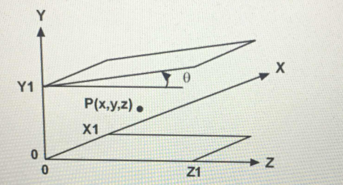
Fig.1 the design of physical problem—electric field by two plates.
One plate is placed on the coordinate plane (XZ plane), while the other is inclined. The second plate on the XZ plane has the same projection, but tilted of at an angle θ with respect to XZ plane. Computation will reveal the electric field distributions along lines parallel to X and Z axis. That is, the point P shifts along the electric field and a line is then plotted.
To work out the electric field, each plate is sliced into small pieces, where every piece is assumed to be like a point charge. At point P (a vector), the summing up of all produced electric fields by each piece at point P, is the electric field. The outcome of step size (each side of piece) is then investigated.
Discussion
Per assignment, the parameters are:
θ=14º, X1=5cm, Z1=12cm, Y1=8.5cm, , ρ is 0.1C/cm² for lower plate and 0.4C/cm² for upper plate.
The point P is then shifted parallel to X axis at y=4.25cm and z=6cm. It moves then parallel to Z axis at y=4.25cm and x=2.5cm. The edging effect (when P is closer to the edge of the space between two plates) is then shown independently.
The point P step size is set to be 0.05X1=0.25cm, and the charged plate step size is 0.1cm, 0.01cm, and 0.001cm. The central element (no major fringe effect) is 0.2~0.7 times X1, Y1, Z1.It is because it stays safely inside the two plate’s central space. Three plots were drawn for each charged plate division’s step size.
Two plots were used for field in the fringe and one plot for field in the center. The assignment’s programs are listed in the MATLAB code’s appendix.
For P point, the electric fields along x-direction in the center are plotted as follows:
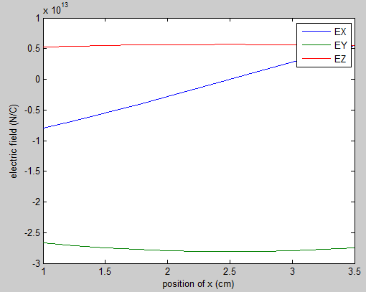
Fig. 2 Electric field in the center, along x direction. y=4.25cm and z=6cm. Three curves matches up to the electric field components.
It is comprehensible that just E_{x} changed considerably along the line. Ex=0 for x in the middle, and the electric field along x-direction varying linearly The Ez is almost constant, and Ey displays a parabolic dependence.
Therefore, if x is moved between -0.2X1~0.2X1, the electric field is destabilized:
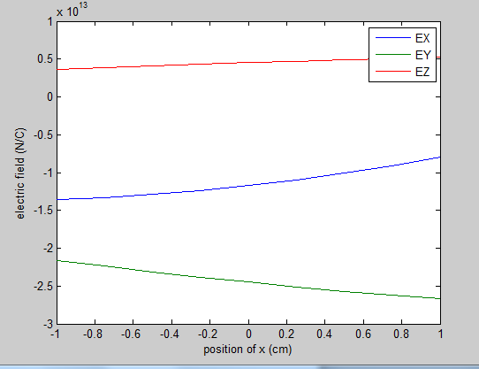
Fig. 3 Electric field between -0.2X1~0.2X1, viewing the electric field variation from central field values.
Towards 0.7X1~1.2X1, the electric field is like this:
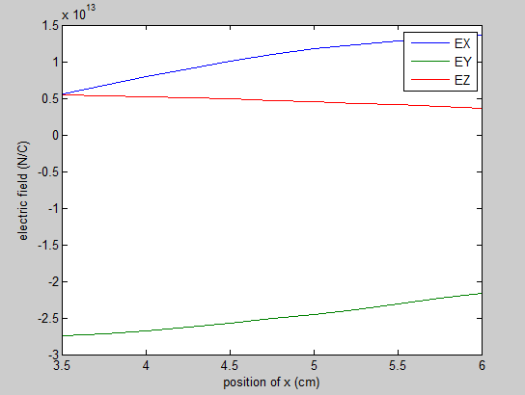
Fig.4 Electric field all along x between 0.7X1-1.2X1, revealing that electric fields in Y and Z direction weakened, whereas the electric field in X direction increase. The X direction electric field is like a smoothen arctan curve, where the absoulte value is 0 in the center, and amplify towards the edge, as less electric field cancelling each other. Moving further out will lessen the electric field in X direction.
Now the effect of steps.
Redo the figure 2:
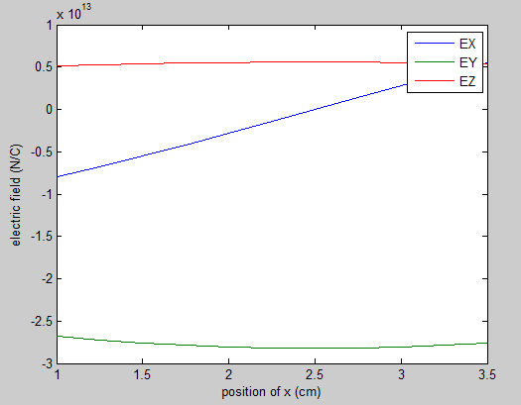
Fig. 5, the same physical problem as figure 2, except that the step is 0.01cm.
computation takes longer, but no much alteration in the field.
Redo the figure 3:
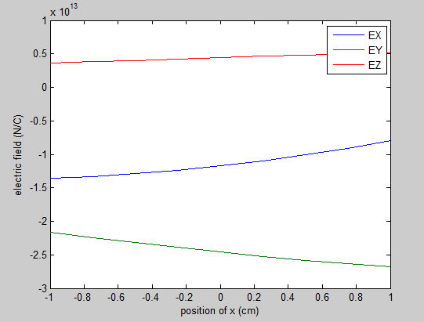
Fig. 6 Redo the figure 3 with better precision.
Redo the numeral 4 with better accuracy:
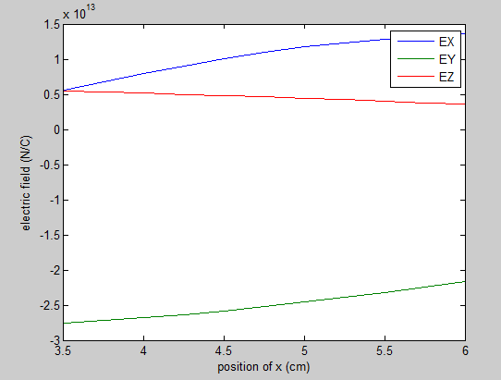
Fig.7 Redo of outline 4 with better accuracy.
No much enhancement as accuracy goes up. As this is a numerical replication, it can be concluded that 0.1cm accuracy for separating the plates is good enough.
Finally, the 0.001cm precision:
Fig.8-10 The three figures replicate the same thing for fig.2-4, and there is no further enhancement by cutting the plates to smaller pieces, except for wasting more computational and calculation power.
Now progress on the Z-axis, the setting is x=2.5cm, y=4.25cm, and z contrasts from 0.2Z1 to 0.7Z1, with 0.05X1=0.25cm as step for electric field point.
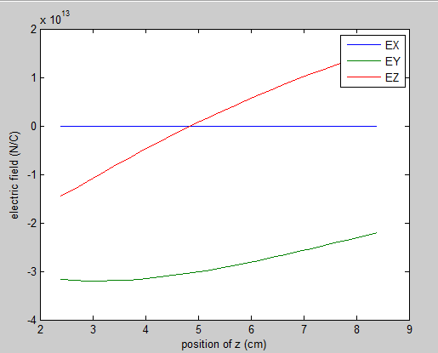
Fig.11, the electric field as a function of field position in z. Step size 0.1cm for plates.
The Ex element is zero as a consequence of the symmetry along the X direction. The Ez linearly moves as electric field swipes through Z. The Y direction field is parabolic.
lengthen along negative Z to see fringe effect:
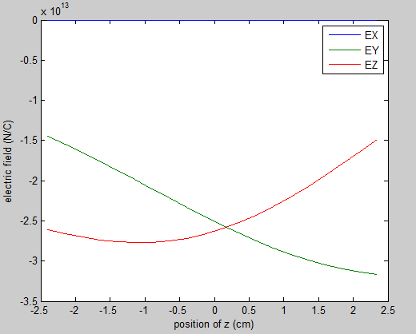
Fig.12, negative Z direction. The Ey is certainly parabolic, and Ez goes to maximum negative before going back to 0.
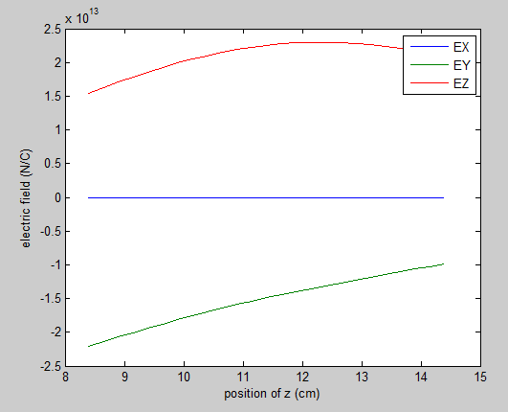
Fig.13 the positive Z direction.
The electric field element Ez indeed amplify to the positive maximum and then goes down. The Ey shows the midpoint has largest electric field magntitude, and edging has smaller electric field.
Decrease the step to 0.01cm:
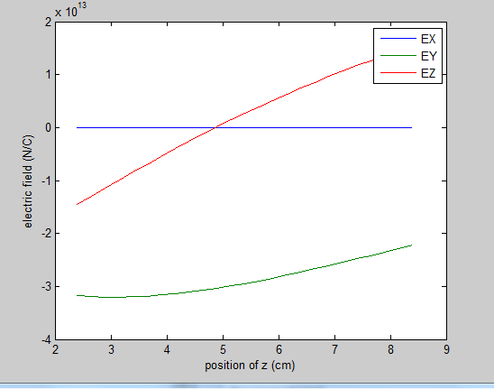
Fig.14 Redo the outline 11 with better accuracy, no much alteration.
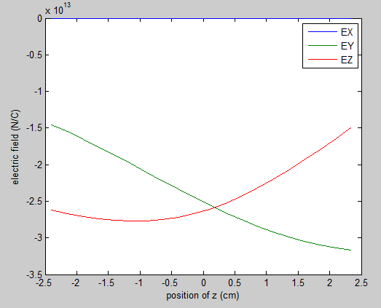
Fig. 15, redo the outline 12 with better accuracy, no enhancement.
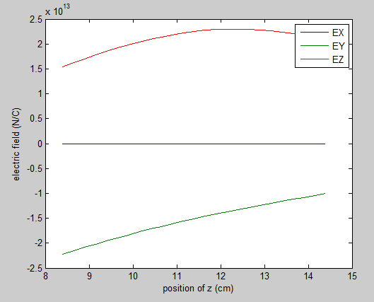
Fig.16 Redo the field for outline 13, no enhancement.
And so the accuracy of 0.1 cm for plate separation is good enough. No need for extra accuracy. 0.001cm outcome would be exactly the same, just computationally more dear.
Conclusion
Thus,the report is disserting the numerical integration for a static electricity problem. The distribution of electric field is vital as this is an ordinary setting of variable resistor, where the angle is modifiable to attain various capacitance values.
The electric field is mostly at a 90 degree angle towards the plates in the center, but there is edging effect on the edge of the capacitor space, where electric field parallel to the plate becomes more vital.
The report also reveals the magnitude of step size for numerical integration, and when diminishing step size would not advance the result, it is time to bring to a halt and admit the current step size as most favorable, to save computation memory and time consumption.
Appendix
MATLAB Code:
The electric field calculator computational function:
function [ex,ey,ez] = efieldcalculator (x1,y1,z1,theta,rho1,rho2,x,y,z,step);
% x1,y1,z1 is the plate size,theta is the angle, rho1 rho2 are charge
% densities, x,y,z are the coordinates of the field point, step size is the step for grid on the plate
k=9*10^9; %the constant k = 1/(4pi epsilon0)
% the unit of length is centimeters, therefore the E field has unit of 10^4
% N/C
% e1 calculation:
e1x=0;
e1y=0;
e1z=0;
for xp1=(step/2):step:(x1-step/2) % xp1, the plate's x-axis point, goes from 0 to x1, but use central point of the step to make total counts right
for zp1=(step/2):step:(z1-step/2) % same applies to zp1
em=rho1.*step.*step.*k./((xp1-x).^2+y.^2+(zp1-z).^2); %the magnitude of e field
e1x=e1x+em.*(x-xp1)./sqrt((xp1-x).^2+y.^2+(zp1-z).^2); %x field
e1y=e1y+em.*y./sqrt ((xp1-x). ^2+y.^2+(zp1-z).^2); %y field
e1z=e1z+em.*(z-zp1). /sqrt ((xp1-x). ^2+y.^2+(zp1-z).^2); %z field
end
end
%e2 calculation
e2x=0;
e2y=0;
e2z=0;
for xp2=(step/2):step:(x1-step/2) %xp2 is the same as xp1
for zp2 = (step/2):step:(z1/cos(theta)-step/2) % the zp2 goes from 0 to z1/cos(theta), it goes along the tilted surface
em=rho2.*step.*step.* k./((xp2-x).^2+(y1+zp2.*sin(theta)-y).^2+(zp2.*cos(theta)-z).^2); %the magnitude of e field
e2x=e1x+em.*(x-xp2)./sqrt((xp2-x).^2+(y1+zp2.*sin(theta)-y).^2+(zp2.*cos(theta)-z).^2); %x field
e1y=e1y+em.*(y-y1-zp2*sin(theta))./sqrt((xp2-x).^2+(y1+zp2*sin(theta)-y).^2+(zp2.*cos(theta)-z).^2); %y field
e1z=e1z+em.*(z-zp2.*cos(theta))./sqrt((xp2-x).^2+(y1+zp2*sin(theta)-y).^2+(zp2.*cos(theta)-z).^2); %z field
end
end
ex=e1x+e2x;
ey=e1y+e2y;
ez=e1z+e2z;
end

The program to produce Fig 2:
X1=5; % May , X1 in cm
Z1=12; % 12th, Z1 in cm
Y1=(X1+Z1)/2; % Y1 in cm
Year=1992;
theta=(Year-1985)*2*2*pi/360; %angle in radian
rho1=0.1;% in C/cm^2
rho2=0.4;% in C/cm^2

%plot 1: E field as function of x
step=0.1; %0.1cm step
x=0.2*X1:0.05*X1:0.7*X1; %0.05 X1 step
y=0.5*Y1;
z=0.5*Z1;
[ex1, ey1,ez1]=efieldcalculator (X1,Y1,Z1,theta,rho1,rho2,x,y,z,step); %unit in N/C
plot(x,ex1*10000,x,ey1*10000,x,ez1*10000)
legend('EX','EY','EZ')
xlabel('position of x (cm)')
ylabel('electric field (N/C)')

The programs to produce Fig 3 and 4
x=-0.2*X1:0.05*X1:0.2*X1; %0.05 X1 step
y=0.5*Y1;
z=0.5*Z1;
[ex1,ey1,ez1]=efieldcalculator (X1,Y1,Z1,theta,rho1,rho2,x,y,z,step); %unit in N/C
plot(x,ex1*10000,x,ey1*10000,x,ez1*10000)
legend('EX','EY','EZ')
xlabel('position of x (cm)')
ylabel('electric field (N/C)')

x=0.7*X1:0.05*X1:1.2*X1; %0.05 X1 step
y=0.5*Y1;
z=0.5*Z1;
[ex1,ey1,ez1]=efieldcalculator (X1,Y1,Z1,theta,rho1,rho2,x,y,z,step); %unit in N/C
plot(x,ex1*10000,x,ey1*10000,x,ez1*10000)
legend('EX','EY','EZ')
xlabel('position of x (cm)')
ylabel('electric field (N/C)')

Changing the step size to 0.01 and 0.001 produce figure 5-10.
The program to produce figure 11:
X1=5; % May , X1 in cm
Z1=12; % 12th, Z1 in cm
Y1=(X1+Z1)/2; % Y1 in cm
Year=1992;
theta=(Year-1985)*2*2*pi/360; %angle in radian
rho1=0.1;% in C/cm^2
rho2=0.4;% in C/cm^2

%plot 2: E field as function of z
step=0.01; %0.1cm step
z=0.2*Z1:0.05*X1:0.7*Z1; %0.05 X1 step
y=0.5*Y1;
x=0.5*X1;
[ex1,ey1,ez1]=efieldcalculator (X1,Y1,Z1,theta,rho1,rho2,x,y,z,step); %unit in N/C
plot(z,ex1*10000,z,ey1*10000,z,ez1*10000)
legend('EX','EY','EZ')
xlabel('position of z (cm)')
ylabel('electric field (N/C)')

Programs to produce figure 12 and 13:

z=-0.2*Z1:0.05*X1:0.2*Z1; %0.05 X1 step
y=0.5*Y1;
x=0.5*X1;
[ex1, ey1,ez1]=efieldcalculator (X1, Y1, Z1, theta,rho1,rho2,x,y,z,step); %unit in N/C
plot(z,ex1*10000,z,ey1*10000,z,ez1*10000)
legend('EX','EY','EZ')
xlabel('position of z (cm)')
ylabel ('electric field (N/C)')

z=0.7*Z1:0.05*X1:1.2*Z1; %0.05 X1 step
y=0.5*Y1;
x=0.5*X1;
[ex1, ey1, ez1]=efieldcalculator (X1, Y1,Z1,theta,rho1,rho2,x,y,z,step); %unit in N/C
Plot(z,ex1*10000,z,ey1*10000,z,ez1*10000)
legend('EX','EY','EZ')
Xlabel('position of z (cm)')
ylabel ('electric field (N/C)')

Changing the step size to 0.01 will produce figures 14-16.

